Refactoring:

- Refactoring is a technique for improving existing code and for restructuring an existing body of code, altering its internal structure without changing its externally observable behavior.

- Refactoring does not fix bugs, but it may help find bugs by scrutinizing code. It may also reduce the further introduction of bugs by cleaning-up code.

- Refactoring does not add new functionality to the system, but it will ease the further adding of new functionality.

- It is an essential part of agile software development such as Extreme Programming or incremental development.

The goal of refactoring:

  - Improve quality

  - Improve productivity

  - Improve sustainability of development

1-Refactoring target: Improving design quality, maintainability, readability, and simplify code structure

Build1:
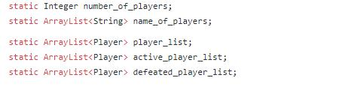

Build2: instead of having 4 different arrays to keep players with different states, we added “state_player” , which is an Enum (Playing, waiting, dead), to player . Also, required functions are added to get different type of players.
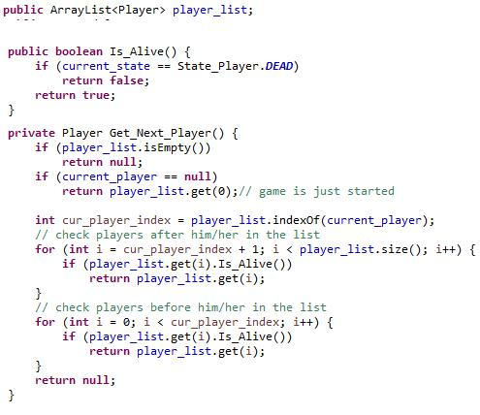

2-Refactoring target: maintainability

Reinforcement, Attack, Fortification methods are moved from game_model to player_model to be able to apply strategy pattern later.
3- Refactoring target: maintainability, readability

Methods related to graph such as Depth first search (DFS) and Exist_path are moved from map to map_helper and are set as static method.

Therefore we had to refactor Is_Valid method in Map_Model to be compatible with new changes.

4- All controllers are initialize in main method, instead of initializing game_generator_controller

in the game_model

Build1:
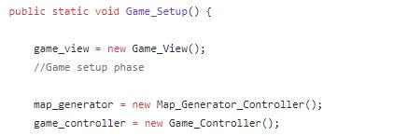

Build2:

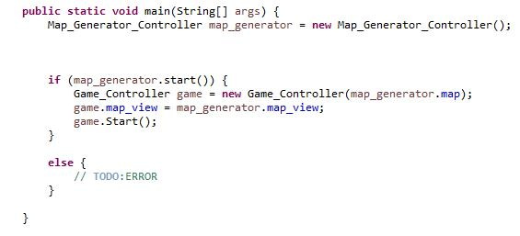

Build#3:

- Behaviour Strategy pattern necessitated a modified move model design

- all move methods were modified to have associated data structures similar to
last build's attack_model.

- Behaviour Strategy pattern required an adapted console_view to handle move generation input from users. This was automated for the AI players at the time of the move.

- Attack_model now generated entirely from the player move call rather than from the game model. -> required refactoring the player to have access to the game map from the game model while removing any strategy from the game model itself

